INSTRUCTION MANUAL FOR SUSPENSION ROTATOR SR-100
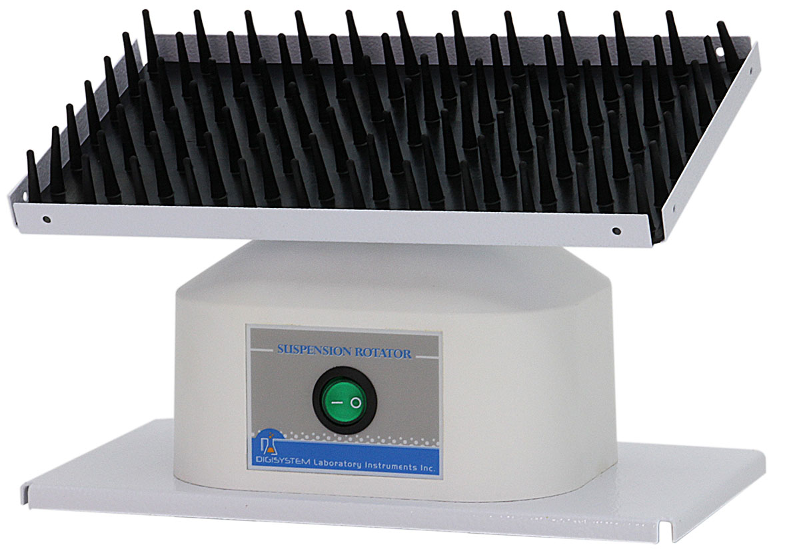
Dimple mat

ON/OFF Switch

Warnings:
* Do not remove the rotator during operation.
* Place the mixer securely away from the edge of bench to avoid the rotator falling off the bench top.
* Do not disassemble the rotator by yourself. In the event of a malfunction, the rotator should be repaired by a qualified technician. Before repairing, turn off the power.

Steps:
- Place the rotator on a flat and stable bench top. Plug it into a properly grounded outlet which corresponds with the electrical requirements on the label back on machine.
2. Put the specimen into a container and tight closed , then place the container on the ‘Dimple mat’.
3. Place ‘ON/OFF Switch’ at ‘ON’ position, and then the machine starts rocking.
4. Containers can be loaded and unloaded during the machine operating.

Maintenance and care:
Keep the machine clean all the time, so no routine maintenance is required. Cleaning can be done with a damp cloth. Avoid the use of solvents as they may damage the machine housing.

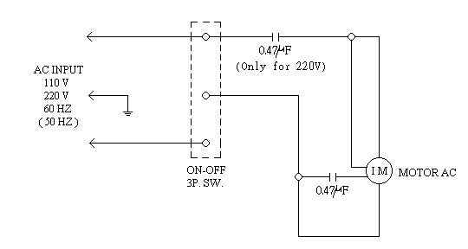
Circuit Diagram

Troubleshooting Guide
Caution: Always disconnect the power cord before troubleshooting.
Trouble | Cause | Remedy
Instrument inoperative. | Power cord not connected to outlet. | Plug in the power cord.
Instrument inoperative. | Dead power output. | Change to different output.
Instrument inoperative. | Defective electronic component. | Contact your distributor for repair.
Power is on, but the power switch is not illuminated. | Fuse is burnt. | Replace a new fuse.
Power is on, but the power switch is not illuminated. | ON/ OFF switch is broken. | Contact your distributor for repair.
Motor doesn’t work. | Motor is broken. | Contact your distributor for repair.
Motor doesn’t work. | ON/ OFF switch is broken. | Contact your distributor for repair.

